

HAWASSA UNIVERSITY

INSTITUTE OF TECHNOLOGY
FACULITY OF INFORMATICS
DEPARTMENT OF COMPUTER SCIENCE

Internship Report on Software Development
at Wegagen Bank

Student Name: Yeamlak sisay
Mentor Name: Mr. Habtamu Assegahegn
Hosting Company: Wegagen Bank S.C
Duration of Apprenticeship: June 23, 2026 -September 1, 2026
Host Department: Core Application Management Service

Date of Submission: September 18,2026

Declaration
I declare that this internship activity report is my original work, prepared based on the activities, experiences, and knowledge gained during my internship period from June 23 to September 1, 2026 at Wegagen Bank where I participated in software development.
All sources of information used in preparing this report have been appropriately acknowledged

Approval of the Mentor
This serves as confirmation that the practical attachment report titled "software Development Internship at Wegagen Bank" has undergone a thorough review and is officially approved for submission.
The review and evaluation of this report were carried out by the Mentor Habtamu Assegahegn, who confirms that the content meets the required academic and professional standards for a practical attachment report and is fit for submission.

Acknowledgements
I would like to express my sincere appreciation to Wegagen Bank for accepting me as an intern and providing me with a valuable professional learning environment. I would like to thank the staff members of the Core Application Management Service Department for their guidance, support, cooperation, and willingness to share their knowledge and experience.
My special thanks go to my department advisor, Mr. Habtamu Assegahegn and his team mates Mr. Abdulrezak and Mr. Robel, for their supervision, constructive feedback, and continuous guidance throughout the internship and report preparation.

Executive Summary
This report documents a two-and-a-half-month internship completed at Wegagen Bank S.C., within the Core Application Management Services department, from June 23 to September 1, 2026. The internship centered on the design and development of a mobile application — the Smart Agent & Branch Queue and Forex Finder system — aimed at addressing a practical operational problem observed at the bank's branches: long customer queues for routine service.
The first phase of the internship focused on orientation and study, gaining an understanding of how quality software products are delivered within a regulated banking environment and how the bank manages and supports its core systems. Building on this foundation, the internship moved into hands-on development, using Node.js and Express to build a stable backend — including routing, database connectivity, middleware, and services — before layering a React Native and Expo frontend on top, developed in TypeScript. The resulting application allows customers to reserve their position in a branch queue remotely rather than waiting in line, while also giving staff and customers visibility into daily foreign-exchange rates, in line with the bank's internal rate-update policy. Additional features included loan and card management support and appointment scheduling, with Clerk used for authentication and email-based notifications.
Beyond the technical build, the internship provided insight into how software decisions are shaped by organizational policy and risk considerations in a financial institution, and how backend architecture decisions made early in a project affect everything built afterward. The experience strengthened both technical skills, in backend and mobile application development, and professional skills, in working within a structured, policy-driven organization, and it clarified a personal interest in pursuing backend development further.

Table of Contents
Declaration 2
Approval of the Mentor 2
Acknowledgements 2
Executive Summary 3
Chapter One: Background of Wegagen Bank 6
Introduction 6
Brief History of Wegagen Bank 6
Main Products and Services of Wegagen Bank 7
Main Customers and End Users of Wegagen Bank's Products and Services 8
1.5 Organization and Structure 10
Chapter Two: My Practical Attachment Experience 12
2.1 How I Get into The Company 12
2.1.1 Placement within Wegagen Bank: Core Application Management Service 12
2.2 Workflow in the Core Application Management Service Department 13
2.3 Work Tasks Executed During the Practical Attachment 14
2.3.1 Problem Identification and Requirement Analysis 14
2.3.2 System Planning and Design 15
2.3.3 Backend Architecture and Database Implementation 15
2.3.5 Mobile Application Development 16
2.3.6 Queue Management and Foreign-Exchange Rate Implementation 18
2.3.7 Quality Assurance, System Documentation, and Project Delivery 19
2.4 Materials and Methodology 20
2.5 How well I performed My Work Tasks 24
2.6 Challenges Faced During the Practical Attachment 25
2.7 Measures Taken to Overcome Challenges 27
Chapter Three: Benefits I Gained 28
3.1 Practical Skills 28
3.2 Knowledge Gained in Terms of Theoretical Understanding 29
3.3 Interpersonal Communication Skills Gained 30
3.4 Teamwork Skills 30
3.5 Understanding of Work Ethics 31
Chapter Four: Conclusion and Recommendations 31
4.1 Conclusion 31
4.2 Recommendations 32
References 34
Appendices---------------------------------------------------------------------------------------------------35

Chapter One: Background of Wegagen Bank

Introduction
Wegagen Bank Share Company is one of Ethiopia's leading private commercial banks, providing a wide range of financial services to individuals, businesses, and institutions across the country. In today's world, the banking sector is no longer just about deposits and loans — it is increasingly driven by technology. Digital banking, mobile applications, card payment systems, and automated core banking platforms have become essential to how banks operate and compete. While this digital transformation brings convenience and efficiency, it also introduces challenges such as system reliability, cybersecurity threats, and the constant need for software development and maintenance to keep services running smoothly.
Because of these demands, banks like Wegagen depend heavily on skilled software developers and IT professionals to build, maintain, and improve the systems that power everyday banking services — from mobile and internet banking to card payments and internal enterprise systems. Wegagen Bank's continuous investment in technology reflects its recognition that strong, secure, and innovative digital infrastructure is central to remaining competitive and serving millions of customers reliably.

Brief History of Wegagen Bank
Wegagen Bank S.C. was established on June 11, 1997, by sixteen visionary founders who recognized the important role financial institutions play in driving sustainable economic development. The Bank began operations with an initial paid-up capital of ETB 30 million and started with two branches — Goffa and Meskel — in Addis Ababa.
Over the years, the Bank expanded steadily, introducing new technologies and services to keep pace with a changing financial landscape. In August 2000, it became a pioneer in connecting its branches through a Wide Area Network (WAN). In 2010, it introduced card banking through its "Agar" Visa Debit Card, followed by mobile banking in 2014 and internet banking in 2018. In September 2017, the Bank inaugurated its 23-storey headquarters building on Ras Mekonnen Street, opposite Addis Ababa Stadium — the same building where My internship took place.
More recently, the Bank has continued to modernize its services, launching a digital lending platform called "Efoyta" in July 2024 and a Visa Prepaid International Card in August 2024. Today, Wegagen Bank is among Ethiopia's largest private financial institutions, operating 443 branches across the country under ten district offices, and serving more than 3 million customers

Figure 1.1: Wegagen Bank Head Quarter

Main Products and Services of Wegagen Bank
Wegagen Bank S.C. is one of Ethiopia’s leading private commercial banks, committed to driving financial inclusion, economic growth, and digital banking innovation across the country. Over the years, it has transformed into a customer-centric financial institution delivering a broad portfolio of conventional, interest-free, and technology-driven banking solutions. Some of its main products and services include:
Deposit and Savings Services
One of Wegagen Bank’s core offerings is providing safe and rewarding deposit avenues for individual and corporate clients. These include regular savings accounts, current (checking) accounts, fixed-time deposits, and tailored packages such as youth, women, and diaspora savings accounts. These services encourage a strong savings culture while giving customers flexible access to their funds.

Credit and Loan Facilities
The Bank supports businesses, agricultural enterprises, and individuals by extending various credit facilities. Its financing solutions include working capital loans, term loans, merchandise loans, import/export financing, trade credit, and personal consumer loans. Through responsible lending, the Bank plays a key role in stimulating commerce and industrial activity.
Digital and Electronic Banking (e-Banking)
To ensure 24/7 banking convenience, Wegagen Bank provides an extensive digital ecosystem:
Mobile & Internet Banking: Customers can check balances, transfer funds, pay utility bills, and manage accounts directly from their smartphones or web browsers.
Card Banking (Agar Visa): The Bank issues local proprietary debit cards and internationally co-branded Visa debit and prepaid cards, supported by a widespread network of ATMs and Point-of-Sale (POS) terminals across the country.
Efoyta Digital Micro-Lending: An innovative digital credit service that provides fast, collateral-free micro-loans and automated credit scoring for small businesses, gig workers, and individuals through mobile channels.
Interest-Free Banking (Wegagen Amanah)
Recognizing the diverse financial needs of Ethiopian society, Wegagen Bank provides Sharia-compliant banking services under the brand name Amanah. Governed by strict Islamic jurisprudence, these include interest-free deposit accounts (Wadiah, Mudarabah) and financing mechanisms (Murabaha, Ijarah), offered through dedicated service windows as well as full-fledged independent Amanah branches.

Main Customers and End Users of Wegagen Bank's Products and Services
Wegagen Bank’s customer base spans from individual retail consumers to high-profile corporate conglomerates, institutional entities, and previously unbanked populations. The primary customer groups and their engagement with the Bank's financial solutions are broken down below:
1. Retail and Individual Banking Customers
Individual consumers represent the largest segment by volume, engaging daily with conventional and digital retail banking solutions.
Key Needs:
  - Secure avenues for personal savings and wealth accumulation.
  - Frictionless 24/7 access to account balances, utility bill payments, and P2P funds transfers.
- Customer Sub-Segments
  - Salaried Employees & Professionals: Rely on direct salary deposit accounts, personal consumer loans, and Agar Visa debit cards for Point-of-Sale (POS) and ATM transactions.
  - Youth & University Students: Utilize mobile banking channels and specialized youth savings accounts tailored to support early financial independence.
Without accessible retail services, daily commerce and individual household financial management would face significant friction and cash dependency.
2. Micro, Small, and Medium Enterprises (MSMEs)
MSMEs form the backbone of the domestic economy, requiring flexible credit structures and working capital financing from Wegagen Bank.
- Key Needs:
  - Accessible short-term credit facilities to manage operational cash flow.
  - Seamless merchant collection channels to receive customer payments.
- Services Utilized:
  - Working capital loans and overdraft facilities to finance inventory or raw materials.
  - Merchant POS terminals and merchant QR code/mobile payment solutions for retail storefronts.
3. Corporate and Commercial Entities
Large private corporations, commercial manufacturers, transport companies, and import/export enterprises depend on Wegagen Bank’s institutional capital base and trade finance infrastructure.
- Key Needs:
  - High-volume capital lending for long-term industrial projects and expansion.
  - Facilitation of international trade and cross-border currency clearance.
- Services Utilized:
  - Corporate Internet Banking: Secure multi-user approval workflows for bulk payroll, vendor disbursements, and real-time treasury monitoring.
  - Foreign Exchange Services: Acquisition of foreign currency for raw material importation and overseas supply chain settlement.

1.5 Organization and Structure
Wegagen Bank operates under a Board of Directors and a Core Management team led by the Chief Executive Officer, supported by three Deputy Chief Executive Officers overseeing key functional areas: Operations, Enterprise, and Technology. Under the Technology function, the Bank maintains several specialized units responsible for keeping its digital and core banking systems running securely and efficiently. Some of these units include:
- Core Application Management Services – responsible for managing, maintaining, customizing, and supporting the Bank's core banking system (Oracle Flexcube) and other critical enterprise applications that power day-to-day banking operations. (This is where I worked during my internship.)
- IT Infrastructure and Security Management – manages the Bank's networks, servers, and cybersecurity systems.
- Digital Banking Operations – oversees mobile, internet, agent, and card banking platforms.
- Human Resource Management, Finance, and other administrative departments – support the Bank's overall operations and workforce.
The Core Application Management Services department, where I was placed, plays a central role in ensuring that the Bank's core systems and supporting applications function reliably, are properly maintained, and are continuously improved to meet the Bank's growing operational and customer service needs.
1.6 Work Flow of Wegagen Bank (Core Application Management Services)
The workflow within the Core Application Management Services department follows a clear and practical process designed to resolve issues quickly while maintaining the stability of the Bank's core systems. For example:
- An issue, bug, or system-related problem is reported to the department, typically through a phone call to the office from staff experiencing the problem.
- The team receives the report and takes note of the issue, prioritizing it based on urgency and impact on banking operations.
- The reported issue is discussed during a team meeting, where it is evaluated and assigned to the appropriate team member(s) for resolution.
- The assigned team member investigates the issue and develops or applies a fix.
- Before any change is deployed to the live (production) system, it is first tested in a dedicated test environment to confirm that it resolves the issue without introducing new problems.
- Once the fix passes testing, it is approved and deployed to the live system, restoring normal functionality.
- If necessary, the department documents the issue and resolution for future reference, helping the team respond more efficiently to similar problems.

Chapter Two: My Practical Attachment Experience

2.1 How I Get into The Company
I joined Wegagen Bank through the university's Practical Attachment program, which is designed to connect students with organizations relevant to their field of study. After submitting the application letter from my university, Wegagen Bank responded and I was invited to report to their headquarters, located on Ras Mekonnen Street, Addis Ababa.
When I arrived, I was introduced to the Bank's structure and given an overview of its different departments and how they support the Bank's operations. Given my background in software development, I was placed within the Core Application Management Services department, under the Bank's Technology function — a unit responsible for managing, maintaining, and developing the core banking system and other critical enterprise applications used across the Bank.

2.1.1 Placement within Wegagen Bank: Core Application Management Service
From June 23, 2026, to September 1, 2026, I was placed within the Core Application Management Service under the Information Technology Directorate of Wegagen Bank S.C., stationed at the Bank’s headquarters in Addis Ababa. This department serves as one of the most critical technological pillars of the Bank, tasked with maintaining, optimizing, and extending core digital banking architectures, enterprise service integrations, and customer-facing digital channels that power the institution's day-to-day operations.
Within this department, our assignment centered on Mobile and Web Banking Application Development, specifically building modern, high-performance interfaces and scalable backend services to elevate the Bank's digital service delivery. The digital banking stream functions as a frontline engine for financial inclusion and customer retention by:
- Engineering Responsive Digital Touchpoints: developing a mobile application called "Smart Agent and Branch Queue Management." This project was introduced to me as a solution to a real, everyday problem at the Bank: long customer queues at branches, which waste customers' time and create inefficiencies for branch staff.
- Building Resilient Backend Services: Developing secure, scalable RESTful application programming interfaces (APIs) capable of facilitating seamless business logic and secure data exchange.
This functional area is particularly strategic within Wegagen Bank because it bridges enterprise core backend databases with direct consumer touchpoints, ensuring that account holders experience reliable, secure, and responsive digital interactions.

Supervision and Technical Leadership
My internship engagement was carried out under the close mentorship and direct technical guidance of:
- Mr. Habtamu Assegahegn, Senior Software Engineer, who served as my primary supervisor throughout the deployment period.
Mr. Habtamu provided critical direction in translating enterprise banking workflows into modular, scalable technical requirements. Under his mentorship, I adhered to rigorous software engineering standards, established secure architectural workflows, and integrated real-world fintech design patterns.

2.2 Workflow in the Core Application Management Service Department
The Core Application Management Service Department consists of professionals working on different software development, system management, and application-support activities. Team members are assigned to different projects and tasks based on project requirements and organizational priorities.
During my internship, I group worked on a mobile application related project under the guidance and supervision of my assigned supervisor. The supervisor provided direction, assigned tasks, reviewed our progress, and gave feedback when necessary.

2.3 Work Tasks Executed During the Practical Attachment
During My practical attachment at Wegagen Bank, I worked on different software development activities under the guidance of my assigned supervisor. The internship provided us with an opportunity to apply our academic knowledge to a practical project that addresses a real-world problem in the banking sector.
My major project was the development of a Smart Banking Queue and Forex Finder System. The main purpose of the system was to reduce the inconvenience caused by long queues at bank branches by allowing customers to check queue information and hold their position remotely before visiting a branch. In addition, the platform was designed to provide customers with foreign-exchange rate information, allowing them to view available currency rates conveniently.
Before beginning implementation, I analyzed the problem, identified the expected users and system requirements, prepared the system design, and selected suitable technologies. Throughout the internship, I worked collaboratively under the supervision of my supervisor, received feedback, solved technical challenges, and documented my progress.
The major tasks performed during the internship are described below.

2.3.1 Problem Identification and Requirement Analysis
At the beginning of the project, I focused on understanding the problems faced by customers when visiting bank branches. One of the major problems identified was the long waiting time experienced by customers who need banking services such as cash deposits, foreign-exchange services, and other branch-related services.
To address this problem, I proposed a system that would allow customers to view branch information, check the current queue, obtain an estimated waiting time, and join or hold a queue remotely.
The platform also included a foreign-exchange feature that would allow customers to view currency rates such as the US dollar, euro, and British pound against the Ethiopian birr.
The main users identified for the system included customers, bank employees or agents, and administrators. This stage help me understand the project scope and establish a clear direction for development.

2.3.2 System Planning and Design
After identifying the requirements, I worked on the initial planning and design of the Smart Banking Queue and Forex Finder System. The system was planned as a mobile-based platform that communicates with a backend server through APIs. The mobile application would provide the user interface, while the backend would manage the business logic, user information, queue data, branch information, and exchange-rate data.
During this stage, I designed the overall system architecture and planned how the different components would communicate with one another. I also designed the customer queue workflow, including branch selection, service selection, queue joining, digital-token generation, and queue-status monitoring. In addition, I planned the foreign-exchange rate interface and considered the different access permissions required for customers, employees, and administrators. The proposed design was reviewed with my supervisor before I proceeded with implementation.

2.3.3 Backend Architecture and Database Implementation
The server-side infrastructure and data layer of the Smart Banking Queue and Forex Finder System were architected and implemented using Node.js and Express.js in conjunction with PostgreSQL as the core relational database management system, mediated by Prisma ORM. The backend serves as the centralized orchestration engine responsible for processing incoming client requests from the mobile interface, executing business logic, enforcing strict relational integrity, and serving structured, type-safe RESTful API endpoints. To ensure maintainability, scalability, and clean separation of concerns, the backend was organized around a layered architectural pattern separating the routing mechanisms, controllers, business services, and database persistence layers. User identity verification and access management were integrated via Clerk as a third-party authentication provider, where incoming HTTP requests are intercepted by custom Express middleware to cryptographically validate session bearer tokens prior to reaching protected routes. Database modeling commenced by defining core business entities, their scalar attributes, and their relational mappings within the Prisma schema—encompassing users, branch locations, operational banking services, active queue entries, digital tokens, foreign exchange rates, notifications, and historical queue telemetry. PostgreSQL was utilized to enforce referential integrity and consistency through primary keys, foreign key constraints, unique indexing, and non-null column definitions, while Prisma Client facilitated type-safe query generation and automated schema migrations. unique sequential digital token, logs the active queue state, and persists the transaction to queue history. Comprehensive request validation schemas, centralized exception-handling middleware, and standardized HTTP response codes (such as 200 OK, 201 Created, 400 Bad Request, 401 Unauthorized, and 500 Internal Server Error) were incorporated across all foreign exchange, branch discovery, and queue endpoints, yielding a robust, high-integrity server-side system capable of reliable data exchange with the client application.

2.3.5 Mobile Application Development
The client-facing mobile application was architected and implemented using React Native and TypeScript powered by the Expo framework, functioning as the primary user touchpoint for branch discovery, remote queue reservations, real-time ticket tracking, and foreign exchange telemetry. Development commenced with initializing the Expo environment and establishing a file-based routing architecture via Expo Router, creating an intuitive screen hierarchy encompassing authentication flows, dashboard landing views, branch and agent locators, service selection modules, live queue status monitors, digital token displays, profile configurations, and historical queue records. Identity management, biometrics, and session persistence were integrated via the Clerk Expo SDK (@clerk/clerk-expo) coupled with Expo SecureStore and device-level biometric authentication (such as fingerprint recognition and facial scanning), enabling secure hardware-backed credential storage and frictionless biometric re-authentication alongside standard login protocols. The presentation layer was styled systematically using React Native's native StyleSheet.create API, standardizing responsive layouts, component hierarchy, typographic scales, spacing systems, and platform-specific visual ergonomics across varying viewport dimensions. For the client-server data synchronization layer, an Axios HTTP client was configured with request interceptors to automatically inject bearer authorization tokens retrieved from SecureStore into request headers, enabling secure data transport to protected backend REST endpoints.
The system also supports real time notifications using socket.Io, in which customers and agents
are notified when an event happens.
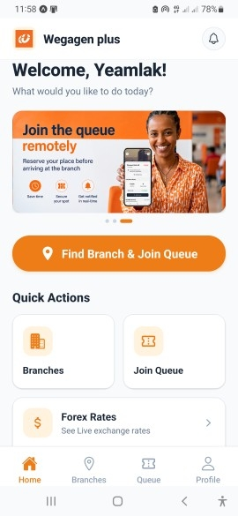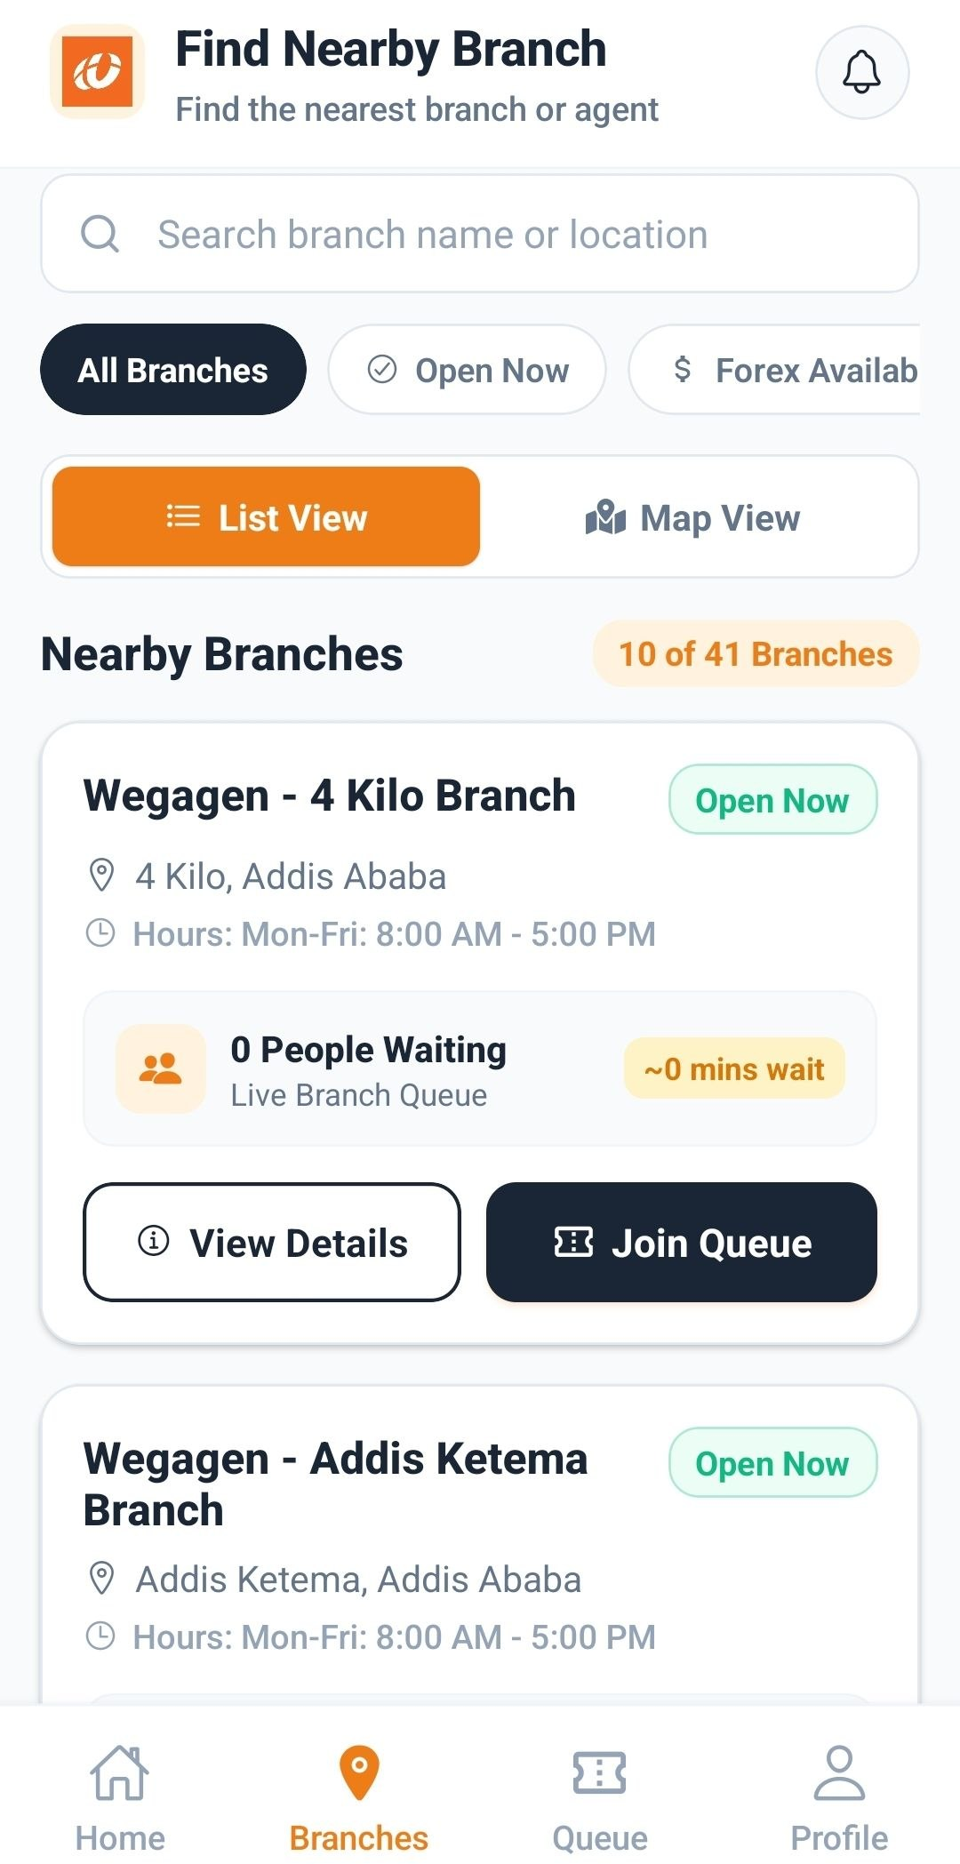

To support in-branch operations, dedicated teller and employee interface screens were designed to allow bank personnel to actively manage customer throughput, view assigned branch service queues, monitor active ticket counters, and advance the queue line by invoking API actions to serve and call the next waiting customer in real time.
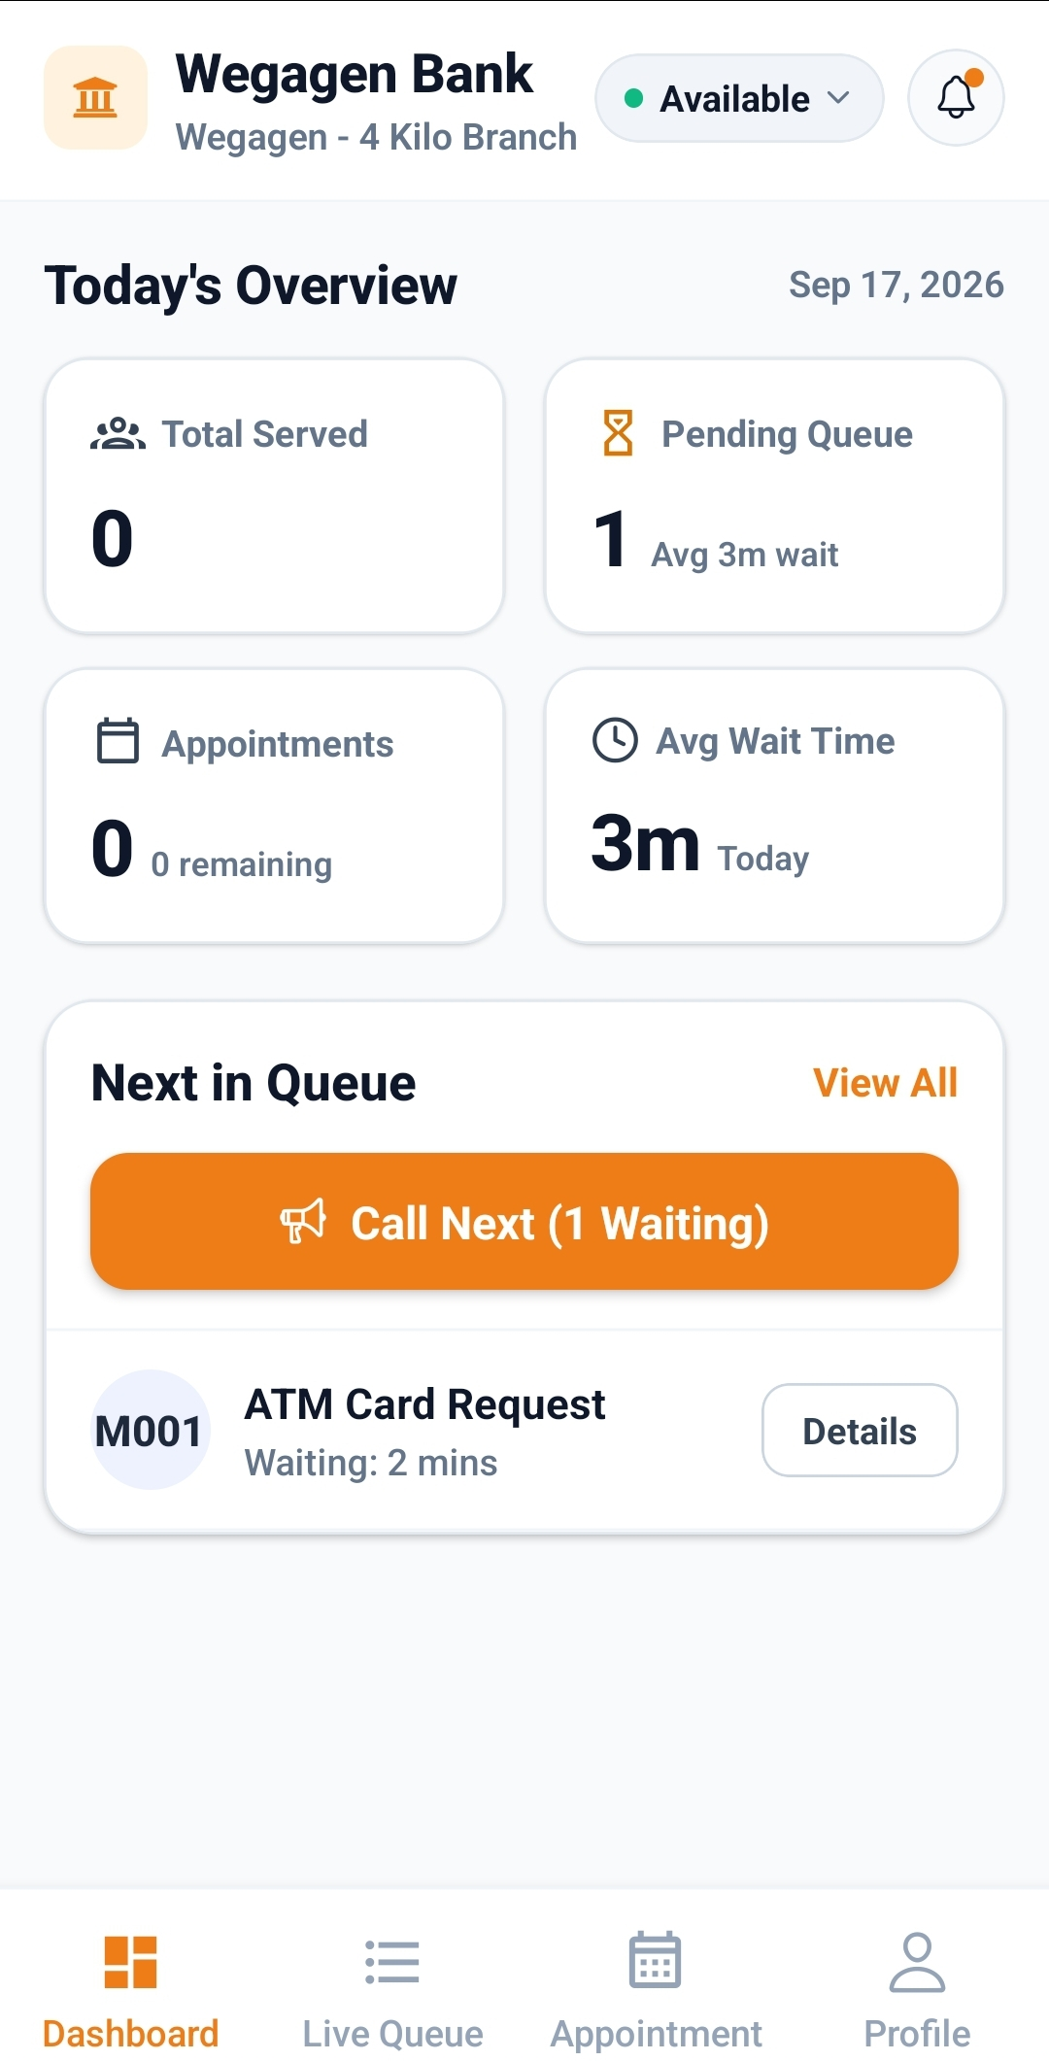

2.3.6 Queue Management and Foreign-Exchange Rate Implementation
The core transactional capabilities of the system were established through the integration of an automated remote queue-management pipeline and a real-time foreign-exchange (forex) rate finder, engineered to streamline in-branch service throughput and provide transparency for currency operations. The queue-management module mitigates physical branch congestion by enabling users to locate a target branch, select a designated banking service, inspect real-time queue length metrics, and receive dynamic wait-time estimations prior to physical arrival. Upon initiating a remote reservation, the backend atomically assigns an indexed digital token representing the user's explicit position, broadcasting status updates to the client interface so users can track queue progression while recording completed, cancelled, or expired ticket states into the persistent queue history for operational analytics and auditability. Concurrently, the foreign-exchange rate finder delivers up-to-date currency valuations against the Ethiopian Birr (ETB)—specifically targeting high-volume foreign currencies such as the US Dollar (USD), Euro (EUR), and British Pound (GBP)—by synchronizing with backend rate services to render structured rate matrices detailing distinct transaction types, including buying and selling margins for both physical cash notes and bank-transfer instruments.The admin can update the foreign currency based on the banks daily estimated currencies.

2.3.7 Quality Assurance, System Documentation, and Project Delivery
API standardization, comprehensive testing, multi-stage debugging, and professional documentation workflows were executed systematically throughout the development lifecycle to ensure platform reliability, cross-stack interoperability, and structured project governance. To establish a dependable integration contract between the mobile client and backend services, RESTful endpoints were defined and cataloged using Swagger/OpenAPI specifications, providing detailed schemas for HTTP request methods, path and query parameters, JSON payload structures, Clerk bearer token authentication requirements, validation rules, and standardized HTTP response codes. Systematic endpoint testing, database transactional verification, and integration stress tests were performed across core functional modules—including user authentication lifecycles, atomic queue token issuance, real-time wait telemetry, and foreign-exchange data retrieval—allowing me to identify and resolve critical edge cases involving network latency, environment configuration mismatches, asynchronous data races, and payload serialization errors. In parallel with technical testing, the development process was accompanied by rigorous documentation and engineering reporting.

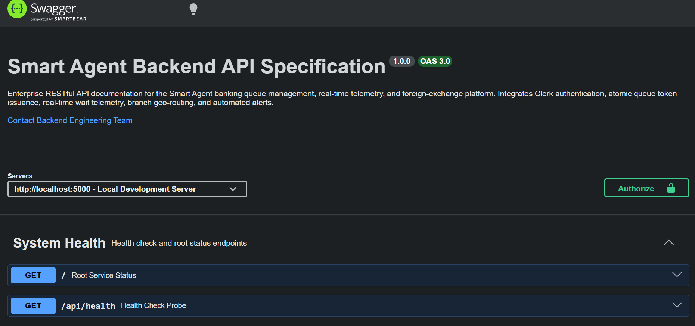

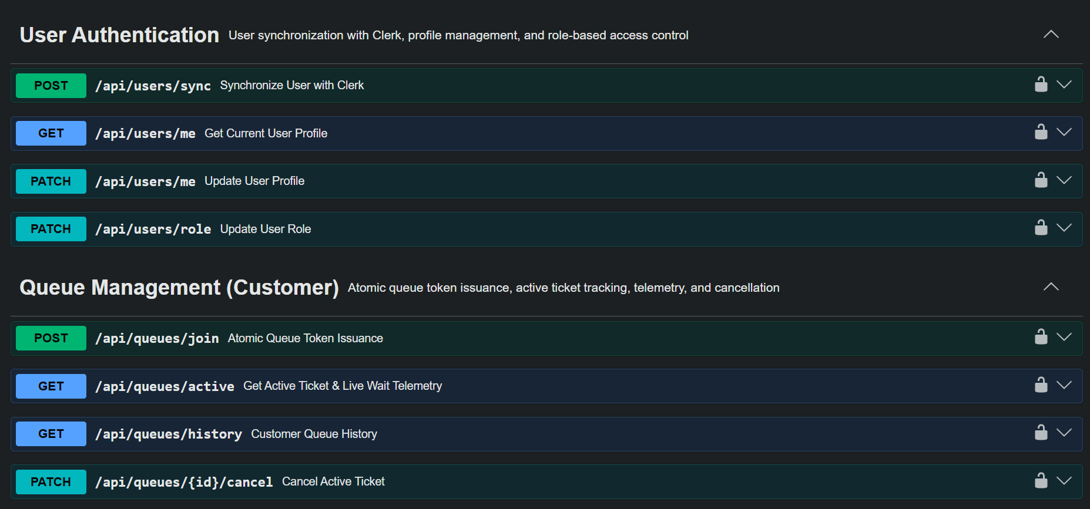

2.4 Materials and Methodology
During my practical attachment at Wegagen Bank, I used different hardware, software tools, frameworks, libraries, and development technologies to design and implement the Smart Banking Queue and Forex Finder System. The project was developed as a mobile-based application supported by a backend server, a PostgreSQL database, and an administrative interface. These tools helped me implement the system’s main functions, including user authentication, branch and service management, digital queue joining, token generation, real-time queue updates, notifications, foreign-exchange rate display, and administrative management.
Development Environment and Materials
The system was developed using a personal computer running Windows 11. Visual Studio Code was used as the primary integrated development environment for writing, organizing, and debugging the application’s source code. Expo Go was used to run and test the React Native mobile application on a physical mobile device during development.
PostgreSQL was used as the relational database management system for storing and managing the system’s data. pgAdmin was used to inspect and manage the PostgreSQL database, execute database-related operations, and verify stored records.
React Native
React Native was the main framework used to develop the mobile application. It enabled me to build the Smart Banking Queue and Forex Finder System for mobile devices using TypeScript-based technologies while maintaining a component-based development approach.
Using React Native, I developed the application interfaces for user authentication, the home page, branch discovery, service selection, queue joining, digital token display, queue status, foreign-exchange rates, profile management, and queue history. React Native also allowed me to create reusable components and organize the application into separate screens that could be maintained and updated more easily.
The application was developed with Expo, which simplified the development and testing process by providing tools for running the application and accessing device features. Expo Go was particularly useful for testing the mobile interface and checking how the application behaved on a physical Android device.
Expo Router
Expo Router was used to manage navigation and routing within the React Native application. It provides a file-based routing structure in which application screens are organized according to the project’s file and folder structure.
I used Expo Router to organize the different screens of the application, including authentication screens, customer screens, profile pages, queue-related screens, and administrative-related routes where applicable. This helped make navigation more structured and allowed users to move between different sections of the application based on their roles and available permissions.
TypeScript
TypeScript was used in both the mobile application and the backend. It extends JavaScript by providing static type checking, which helps identify certain errors during development before the application is executed.
Node.js and Express.js
Node.js was used as the runtime environment for developing the backend of the system. It allowed the application to execute server-side TypeScript code and handle requests from the mobile application and administrative interface.
Express.js was used as the backend web framework for creating the server and implementing the RESTful APIs. I used Express.js to organize routes, handle HTTP requests, validate incoming data, manage application logic, and return responses to the client.
Prisma ORM
Prisma ORM was used to connect the Node.js and Express.js backend to the PostgreSQL database. It provided a structured and type-safe way to define database models and perform database operations without writing every query manually.
I created Prisma models for the main entities of the system, such as users, branches, services, queue entries, tokens, foreign-exchange rates, notifications, and queue history. These models helped define the relationships between the different entities and maintain consistency in the database structure.
Prisma was also used to create, retrieve, update, and delete records during application operations. For example, when a customer joined a queue, the backend stored the queue entry and related token information in the database through Prisma.
Clerk Authentication
Clerk was used to provide authentication and user identity management for the application, and also it includes the Email sending mechanism. It helped manage user registration, login, session handling, and authenticated access to protected parts of the system.
I integrated Clerk into the React Native application so that users could securely sign in and access their accounts. The authenticated user information was also connected to the backend, allowing the system to associate actions such as joining a queue, viewing queue history, and managing profile information with the correct user.
Authentication and authorization were important because the system included different roles, such as customers, bank employees or agents, and administrators. Each role required access to different functions of the system.
Socket.IO
Socket.IO was used to support real-time communication between the backend and connected clients. It was particularly useful for the queue management functionality, where changes in queue status needed to be reflected without requiring users to manually refresh the application.
Through Socket.IO, the system was designed to send real-time queue updates and notifications to relevant users. For example, changes in queue progress, service completion, cancellation, or other queue-related events could be communicated to users while they were using the application.
Bruno API Client
Bruno was used to test and verify the backend APIs during development. It allowed me to send requests to different endpoints, inspect responses, test request parameters, and identify errors before integrating the APIs with the mobile application.
I used Bruno to test operations such as user-related requests, branch and service retrieval, queue joining, token generation, queue status updates, foreign-exchange rate requests, and administrative operations. Its lightweight design made it convenient for API testing without requiring significant storage space.
Testing the APIs independently helped me identify whether problems originated from the backend, database, or frontend integration.
Git and GitHub
Git was used as the version control system for tracking changes made during the development process. It allowed me to create commits, review previous changes, and maintain different versions of the project source code.
GitHub was used to host the project repository and maintain a remote copy of the source code. It also provided a way to organize the project, back up the code, and track development progress.
Methodology Followed
Development followed a practical, sequential process. I began by identifying the core problem — long waiting times at bank branches — and defining the main requirements: authentication, branch and service info, queue joining, digital token generation, queue status monitoring, forex rate display, notifications, and admin management.
Based on these requirements, I designed the system architecture (mobile frontend, backend server, PostgreSQL database, and admin interface) and built the database models using Prisma, with backend APIs implemented in Node.js, Express.js, and TypeScript. I then built the mobile application with React Native, Expo, and Expo Router, connected it to the backend, integrated Clerk for authentication, and used Socket.IO for real-time queue updates and notifications.
Finally, I tested the system using Bruno, Expo Go, and pgAdmin — checking core features, fixing implementation issues, and verifying communication across the frontend, backend, and database to improve reliability and usability.

2.5 How well I performed My Work Tasks
At the beginning of my practical attachment, several aspects of the development process were new to me. Although I had some previous experience with React, React Native was new, and I needed time to understand mobile application development and become familiar with the tools and technologies used in the project. Working with technologies such as Expo, Prisma, Clerk, and Socket.IO also required additional learning and practice. I mainly relied on official documentation to understand these technologies and apply them correctly during development.
In addition to the technical challenges, adjusting to the internship routine required commitment and proper time management. Since the internship workplace was in Addis Ababa and I live in debrezeit/Bishoftu, I had to wake up at around 5:00 a.m. to prepare and arrive at the office on time. Maintaining this routine while learning new technologies and completing development tasks helped me improve my discipline, punctuality, and sense of responsibility.
As the project was developed individually, managing the entire development process was one of the main responsibilities I handled. I worked on different parts of the system, including the backend APIs, database models, authentication, mobile application, real-time communication, queue management, foreign-exchange rate functionality, and administrative interface. This required me to organize the work carefully, understand how the different components were connected, and solve problems independently.
I followed a daily and weekly work plan to organize my tasks and maintain progress. I divided the project into smaller activities and worked on the different features step by step. I also used Bruno to test the backend APIs and verify whether the endpoints were working as expected before and after integrating them with the frontend.
Throughout the internship, I received positive feedback from my supervisor, who was pleased with the progress and functionality of my work. He also suggested improvements that helped me refine the system and improve certain aspects of its design and implementation. I considered this feedback during the development process and made adjustments where necessary.
By the end of the practical attachment, I had completed the planned project features and gained practical experience in developing a full-stack application. I was able to design relational database models, develop RESTful APIs, integrate authentication, implement real-time communication, and build both customer and administrative interfaces. Overall, the internship improved my technical knowledge, problem-solving ability, independence, time management, and confidence in developing software systems.

2.6 Challenges Faced During the Practical Attachment
During my time at Wegagen Bank, I faced several challenges that tested my ability to learn, adapt, and problem-solve. Unlike working within an established codebase, I was building the "Smart Agent and Branch Queue Management" application largely from scratch, which brought its own unique set of difficulties — from learning an unfamiliar framework to making architectural decisions with no existing code to guide me. Each challenge, however, taught me something valuable and contributed to my growth as a developer throughout the internship.
1. Learning React Native and Expo from the Ground Up
The most significant and persistent challenge I faced was learning React Native and Expo, a mobile development framework I had little prior hands-on experience with. While I had some general programming background with react, building a real mobile application required an entirely different mindset from web development — understanding how components render on mobile devices, how navigation works between screens, how to handle mobile-specific behavior, and how Expo's tooling fit into the development and testing workflow.
Because there was no existing codebase to learn from, I could not simply read through someone else's implementation to understand how things were supposed to work. Instead, I had to learn the framework's concepts directly — through documentation, experimentation, and trial and error — while simultaneously deciding how to structure the application myself.
2. Designing the Application Architecture from Scratch
Since the application was built from the ground up, I was also responsible for making foundational decisions that a developer joining an existing project would not normally have to make — how to structure the frontend screens, how the backend APIs should be organized, and how data would flow between the customer-facing app, the queue system, and agent assignment logic. Without an established pattern to follow, I had to think carefully about these decisions, knowing that mistakes made early in the architecture could cause bigger problems later in development.
3. The API Integration Bug
The most notable technical challenge I faced was connecting the React Native frontend to the Express/Node.js backend using Axios. Even though both sides of the application were built by me, getting them to communicate correctly was far from straightforward. Requests sent from the mobile app were not always reaching the backend as expected, and responses were not always being handled correctly on the frontend side — issues that could stem from anything as small as an incorrect endpoint URL, mismatched data formats between the request and what the backend expected, or how the app handled asynchronous responses.
Resolving this required systematically checking each part of the communication chain — verifying the backend endpoints were working correctly on their own, confirming the frontend was sending requests in the right format, and tracing how responses were being received and processed in the app. When I could not resolve the issue on my own, I brought it to my supervisor, Mr. Habtamu Assegahegn, who helped me pinpoint the exact cause and understand the correct way to structure the communication between the two sides of the application.
4. Balancing Learning with a Demanding Schedule
Alongside these technical challenges, I also had to manage the practical demands of the internship itself. Waking up around 5:00 AM each day to reach the office on time because the office was located in Addis Ababa, and I live in Debre Zeit, while simultaneously learning a new framework and building an application from scratch, meant I had to be disciplined about how I used my time and energy each day to stay productive and keep making progress.

2.7 Measures Taken to Overcome Challenges
Despite the challenges I encountered during my practical attachment, I was able to work through each of them by combining patience, self-study, systematic investigation, and guidance from my mentor.
1. Overcoming the React Native/Expo Learning Curve
I approached this by being patient and systematic rather than trying to learn everything about the framework at once. I focused on understanding one concept at a time — navigation, screen components, state handling — starting with whatever I needed for the specific feature I was currently building. I relied on the official React Native and Expo documentation as my primary reference, reading through core concepts and then immediately applying them in the project so they became concrete rather than abstract.
2. Designing the Application Architecture from Scratch
Since there was no existing codebase to guide me, I dealt with this by starting simple and refining as I went, rather than trying to design a perfect structure from the beginning. I built the core functionality first — joining a queue, viewing status, assigning agents — and then improved the structure of both the frontend and backend as my understanding of the requirements became clearer.
3. Fixing the API Integration Bug
To resolve the issue connecting the React Native frontend to the Express/Node.js backend, I traced through the communication chain step by step rather than guessing at a quick fix. I checked the backend endpoints independently to confirm they worked correctly on their own, then verified how the frontend was formatting and sending its requests, and finally checked how responses were being received and handled in the app. This systematic process helped me isolate exactly where the breakdown was happening. When I reached a point, I could not resolve alone, I brought the specific issue to my supervisor, Mr. Habtamu who helped me identify the exact cause and guided me toward the correct fix.
4. Managing the Demanding Schedule
To handle the early mornings and the pressure of learning while building at the same time, I stayed disciplined about my daily routine — preparing the night before and prioritizing my most demanding learning or coding tasks for when I had the most energy and focus. This consistency helped me stay productive throughout the internship despite the early start times.

Chapter Three: Benefits I Gained

3.1 Practical Skills
My internship at Wegagen Bank significantly strengthened my practical, hands-on development skills, particularly in mobile application development and full-stack engineering.
One of the most important areas of growth was my proficiency in React Native and Expo. Coming into the internship with limited experience in mobile development, I had to learn the framework largely on my own while simultaneously building a real application. By the end of the internship, I was comfortable structuring navigation between screens, managing component state, handling asynchronous data, and building a functional, user-facing mobile interface from the ground up.
I also gained meaningful practical experience with TypeScript, learning how static typing helps catch errors earlier in development and makes code easier to maintain
On the backend side, I developed stronger skills in building server-side applications using Express.js and Node.js.

3.2 Knowledge Gained in Terms of Theoretical Understanding
Alongside the practical skills, my internship deepened my theoretical understanding of several important areas of software engineering and system design.
1. Mobile Application Architecture
Working with React Native and Expo taught me the underlying concepts of how mobile applications are structured differently from web applications — how components render on-device, how navigation and screen lifecycles work, and how mobile apps communicate with backend servers over the network. This gave me a clearer theoretical picture of the client-server model in a mobile context, not just in theory but through building it myself.
2. API Design and Client-Server Communication
Through building and debugging the backend APIs for the queue management system, I gained a much stronger theoretical understanding of how client-server communication works — request/response cycles, data formatting (such as JSON payloads), endpoint design, and the importance of consistent contracts between frontend and backend. The API integration challenge I faced was, in many ways, a practical lesson in this theory: I had to understand exactly how HTTP requests are constructed, sent, and interpreted to figure out where the communication was breaking down.
3. Software Development in a Real-World, Production-Oriented Environment
Unlike academic assignments, developing an application meant for real use inside a bank required me to think about reliability, correctness, and maintainability — not just whether the code worked once, but whether it would keep working under real conditions. This gave me a deeper appreciation for good software design principles, including separating frontend and backend responsibilities clearly and writing code that could be understood and extended later.

3.3 Interpersonal Communication Skills Gained
One of the most valuable non-technical outcomes of my internship was the growth in my interpersonal and communication skills, developed mainly through my regular interaction with my supervisor, Mr. Habtamu Assegahegn, and other staff within the department.
At the beginning, explaining technical progress and problems to a supervisor with far more professional experience than me felt intimidating. I was expected to regularly present my progress on the queue management application — what I had built, what was working, and what challenges I was facing. In the early weeks, I sometimes struggled to explain technical issues clearly and concisely, especially when describing bugs like the API integration problem.
Over time, however, these regular presentations became a valuable exercise in communication. I learned how to summarize technical work in a way that was clear and easy to follow, how to describe a problem specifically rather than vaguely, and how to ask for help in a focused, useful way rather than simply saying "it doesn't work." Receiving regular feedback from my supervisor also taught me how to listen actively, accept constructive criticism without becoming discouraged, and apply that feedback immediately to improve my next piece of work.
By the end of the internship, presenting my progress and discussing technical challenges felt far more natural than it had at the start.

3.4 Teamwork Skills
Although much of my development work was done independently, my internship still gave me valuable experience in working as part of a larger team within the Core Application Management Services department. Being placed inside a professional department meant learning how individual work fits into a bigger, shared responsibility — the department's role of keeping the Bank's core systems running reliably.
I saw firsthand how the department handled incoming issues as a team: problems reported by phone were discussed together in team meetings, assigned based on availability and expertise, and tracked through to resolution. Being part of these meetings, even as an intern, taught me how a technical team coordinates around shared priorities and communicates about ongoing work.

3.5 Understanding of Work Ethics
My internship at Wegagen Bank also gave me a much clearer understanding of professional work ethics, shaped by the seriousness and structure of working inside a national financial institution.
Punctuality and Discipline: Reaching the headquarters on time every day required me to wake up around 5:00 AM, since I needed to travel from Debre zeit to Addis Ababa to arrive at the office punctually. This daily discipline taught me that punctuality is not just a personal habit but a form of respect for colleagues, meetings, and deadlines — arriving late or unprepared would have disrupted both my own progress and the team's plans.
Accountability and Ownership: Because I was building an application largely on my own, I quickly learned that the quality and progress of my work depended entirely on my own effort and initiative. Regularly presenting my progress to my supervisor meant I had to take ownership of both my successes and the problems I encountered, rather than hiding difficulties or making excuses.
Confidentiality and Professionalism: Working within a bank's technology department also made me conscious of the importance of confidentiality and responsible handling of systems and data. Since Core Application Management Services deals directly with core banking systems, I understood the need to be careful, professional, and trustworthy in how I approached my work.

Chapter Four: Conclusion and Recommendations

4.1 Conclusion
My two-and-a-half-month internship at Wegagen Bank S.C., within the Core Application Management Services department, was a genuinely transformative experience that helped me connect the theoretical foundations of my Computer Science education with the practical realities of building software for a real financial institution. Starting from an initial phase of studying how quality software is delivered and how the bank manages its core systems, and moving into the hands-on design and development of the Smart Agent & Branch Queue and Forex Finder mobile application, I came to understand that software is not built overnight — it requires a deep understanding of the problem being solved, the constraints of the environment it will run in, and the people who will ultimately use it. Building the backend before the frontend, structuring routes, middleware, and services carefully, and only then layering the user interface on top, taught me that solid software is the product of deliberate sequencing and patience rather than speed.
Working inside a bank, rather than a pure software company, also gave me an appreciation for how policy and process shape technical decisions — understanding, for instance, why the forex-rate feature had to follow the bank's internal daily-update policy rather than pulling from a live external feed, and why every change to a customer-facing system has to be considered carefully in a regulated, trust-dependent environment. This showed me that technical skill alone is not enough; understanding the organization and the rules it operates under is just as important to delivering software that actually works in context.
Technically, the internship deepened my abilities across the stack — from Node.js, Express, and PostgreSQL on the backend, to React Native and TypeScript on the frontend. But more than any single technology, it was the discipline of building the backend from the ground up, routing, database connections, middleware, and services, that I found myself drawn to, and it left me with a genuine interest in pursuing backend development further.

4.2 Recommendations
Based on my internship experience, I would like to offer the following recommendations to improve the program for future students and strengthen the relationship between the university and the industry.
Structured Onboarding for Interns
One of the early challenges I faced was that the first weeks were spent largely on self-directed study — learning how quality software is delivered and how the bank manages its core systems — without a structured, written introduction to the department's tools, coding standards, or expectations. Host departments could shorten this ramp-up period by providing a brief onboarding document covering the development environment setup, the tools and frameworks in use, and the standards a new intern's code is expected to follow. Even a short written guide would let interns move into meaningful, hands-on work sooner.
Pre-Internship Skill Preparation
Several of the technologies I used during the internship — Node.js with Express on the backend, PostgreSQL, React Native with Expo, and third-party services like Clerk for authentication — were tools I had to learn largely on the job. If the university offered short, practical sessions on backend frameworks, mobile app development, database integration, and version control before students begin their internships, students would arrive better prepared and be able to contribute confidently from the very first weeks rather than spending a large portion of the internship on foundational learning.
University and Industry Collaboration
There is currently a noticeable gap between what is taught in the classroom and what is expected in a real, policy-governed environment such as a bank's software department. Strengthening ties between the university and organizations like Wegagen Bank — through guest lectures, joint workshops, or regular communication about which skills are in demand — would help keep the curriculum relevant and better prepare students for the realities of professional, enterprise-grade software development.

References
•Wegagen Bank S.C. (2025). Prospectus for registration of shares currently held by shareholders. Ethiopian Securities Exchange. https://esx.et/wp-content/uploads/2025/03/Wegagen_Bank_S_C_Prospectus-for-Registration-of-Shares-Currently-Held-by-Shareholders.pdf
•Wegagen Bank S.C. (2026). Official website. https://wegagen.com/
•Wikipedia contributors. (2026). Wegagen Bank. Wikipedia. https://en.wikipedia.org/wiki/Wegagen_Bank
•Meta Platforms, Inc. (2026). React Native documentation. https://reactnative.dev/docs/getting-started
•Expo. (2026). Expo documentation. https://docs.expo.dev/
•OpenJS Foundation. (2026). Node.js documentation. https://nodejs.org/en/docs and OpenJS Foundation. (2026). Express.js — Node.js web application framework. https://expressjs.com/
•PostgreSQL Global Development Group. (2026). PostgreSQL documentation. https://www.postgresql.org/docs/
•Clerk, Inc. (2026). Clerk documentation. https://clerk.com/docs

Appendices
Appendix A: Internship Phases and Activities
The internship followed a sequential approach, moving from orientation and study to design, backend development, mobile development, and testing.
Phase | Activities
Orientation and study (first four weeks) | Studied how quality software products are delivered in a regulated banking environment, how the bank manages its core systems, and backend development fundamentals.
Problem identification and requirements | Observed long customer queues at branches; identified users (customers, bank employees/agents, administrators) and defined requirements.
System planning and design | Designed the system architecture, queue workflow (branch selection, service selection, queue joining, digital token generation, status monitoring), and role-based access; design reviewed with the supervisor.
Backend development | Built the backend with Node.js, Express.js and TypeScript: routing, PostgreSQL connection through Prisma, middleware, services, Clerk token validation, request validation and error handling.
Mobile application development | Built the React Native (Expo) application with Expo Router: authentication, branch discovery, queue joining, digital token, forex rates, profile, queue history, and the employee interface.
Real-time features and notifications | Integrated Socket.IO for live queue updates and notifications; email sending through Clerk.
Testing, documentation and delivery | Tested APIs with Bruno, the app with Expo Go, and the data with pgAdmin; documented the API with Swagger/OpenAPI; prepared the final report.

Appendix B: Tools, Frameworks and Technologies Used
Category | Tool / Technology | Purpose
Mobile application | React Native, Expo, Expo Router, TypeScript | Cross-platform mobile UI, file-based navigation, static typing
Backend | Node.js, Express.js, TypeScript | Server runtime, REST API, business logic
Database | PostgreSQL, Prisma ORM | Relational storage, type-safe models and migrations
Authentication | Clerk, Clerk Expo SDK, Expo SecureStore | Sign-in, session handling, secure token storage, email sending
Biometrics | Device fingerprint / face recognition | Biometric re-authentication
Real-time communication | Socket.IO | Live queue updates and notifications
HTTP client | Axios | Mobile-to-backend requests with bearer-token interceptors
API documentation | Swagger / OpenAPI 3.0 | Endpoint specification and contract
Testing | Bruno, Expo Go, pgAdmin | API testing, on-device testing, database inspection
Version control | Git, GitHub | Source tracking and remote backup
Development environment | Visual Studio Code, Windows 11 | Coding and debugging

Appendix C: System Architecture and User Roles
C.1 Architecture
The system is a mobile-based platform that communicates with a backend server through REST APIs. The backend follows a layered pattern that separates concerns:
Layer | Responsibility
Mobile client (React Native / Expo) | User interface, navigation, secure token storage, API calls through Axios, real-time updates through Socket.IO
Routing layer | Maps incoming HTTP requests to controllers
Middleware | Clerk bearer-token validation, request validation, centralized exception handling
Controllers | Handle requests and shape responses
Services | Business logic (for example, atomic queue token issuance)
Persistence (Prisma + PostgreSQL) | Data models, referential integrity, migrations

C.2 User Roles
Role | Capabilities
Customer | Discover branches, select a service, join a queue remotely, track the digital token and estimated wait, cancel a ticket, view queue history, view forex rates, manage profile
Bank employee / agent | View assigned branch queues, monitor active tickets, call the next waiting customer, manage appointments (Dashboard, Live Queue, Appointment, Profile)
Administrator | Update daily foreign-exchange rates according to bank policy, manage users and roles, and oversee administrative operations

Appendix D: Testing Summary
Testing was carried out throughout development using three tools, each covering a different layer of the system.
Tool | Purpose | Areas covered
Bruno | Sending requests to endpoints, inspecting responses and parameter | User requests, branch and service retrieval, queue joining, token generation, queue status updates, forex rate requests, administrative operations
Expo Go | Running the mobile app on a physical Android device | Screen behavior, navigation, queue flow, real-time updates
pgAdmin | Inspecting the PostgreSQL database and verifying stored records | Queue entries, tokens, users, forex rates, queue history

Issues Identified During Testing
- Network latency between the mobile client and the backend
- Environment configuration mismatches
- Asynchronous data races
- Payload serialization errors
Testing the APIs independently in Bruno made it possible to tell whether a problem originated in the backend, the database, or the frontend integration.

